羊水量の測定

MVP, maximum vertical pocket:
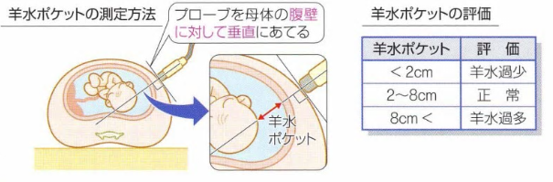

AFI, amniotic fluid index:
